**Please install theano, then simulate an AND gate.**

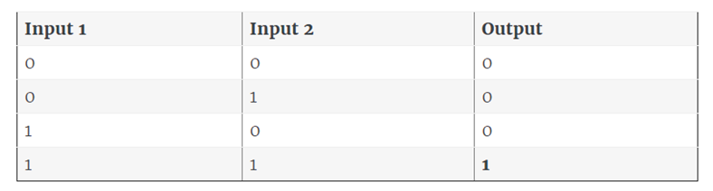

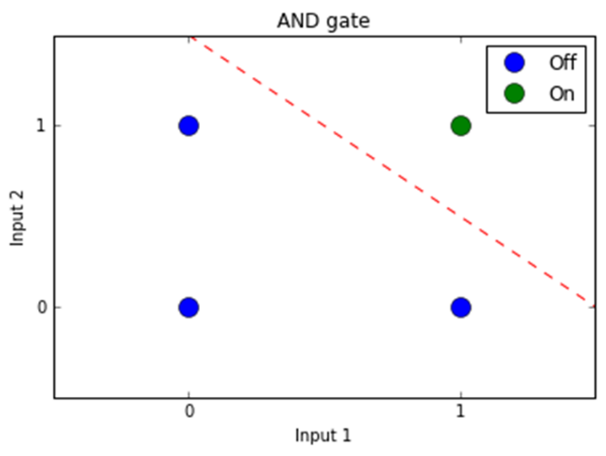

**Hint：**

**inputs = [[0,0], [1,1], [0,1], [1,0]]**

**outputs = [0, 1, 0, 0]**